Paper Bridge Building Contest
SWSC Science Competition 2012 - 2013

Sponsored by Carl Sandburg High School, 13300 S. LaGrange Rd, Orland Park, IL 60462
Eva LaForte (ELaForte@d230.org) & Stacy Verble(Sverble@d230.org)
Rules completed on Monday, October 22, 2012

Description:
To build a paper bridge using only limited quantities of computer paper and masking tape.

Teams & Team Limits:
Work individually or in teams of two. A maximum number of 6 teams will be allowed to compete per round. A limit of 2 teams per school will be allowed to compete per round.

Rules:
Use up to five pieces of computer paper and 50 cm of masking tape to create a self-supporting bridge. Cylindrical flat masses will be placed on top of the bridge to test the bridge. Therefore, the bridge must be open on top to support these masses. The bridge will be suspended across textbooks a distance of 7 inches apart and at least 3 inches off the table to give it height off the desk. (Tape and paper will be provided.) Students will have up to 30 minutes to construct their bridge. The remainder of the time will be used to test the bridges.

Scoring & Tie-Breaker:
The bridge that supports the most mass will be declared the winner. In the event of a tie, the team who constructed the bridge in the least amount of time will be declared victorious.
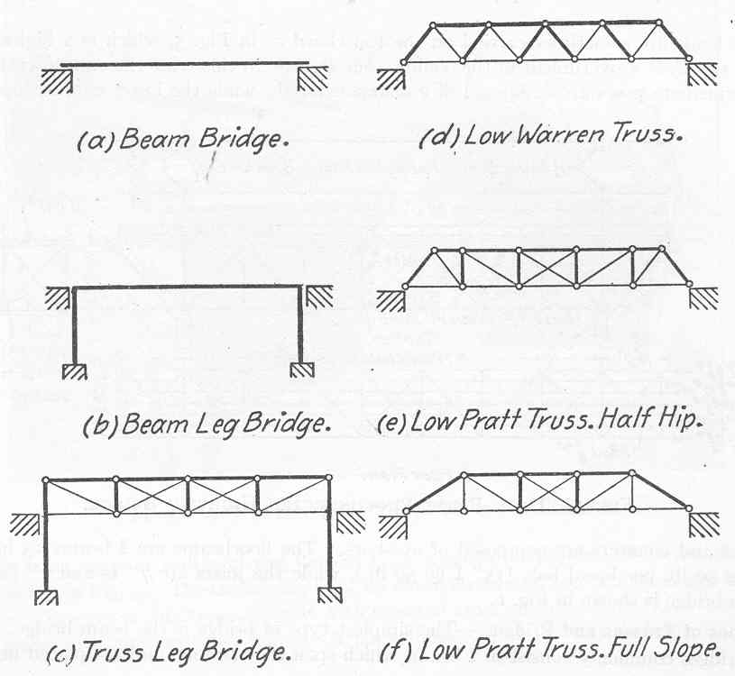
http://okbridges.wkinsler.com/technology/index.html

