3.1 Properties of Parallel Lines – Notes Day 1 Date: ___________

|  |  |  |  |  |
| --- | --- | --- | --- | --- |
| **Learning Targets** | **Help!** | **I’m getting there…** | **I’m almost there…** | **Yes! I totally got this! ☺** |
| 1. I can identify a transversal. |  |  |  |  |
| 2. I can identify alternate interior and alternate exterior angles. |  |  |  |  |
| 3. I can identify corresponding angles. |  |  |  |  |
| 4. I can identify same-side interior and same-side exterior angles. |  |  |  |  |



**Transversal: __________________________________________________________



**Corresponding Angles: _________________________



___________________________________________ _



**Alternate Interior Angles: ______________________



____________________________________________



**Alternate Exterior Angles: ______________________



_____________________________________________



**Same-side Interior Angles: ______________________



_____________________________________________



**Same-side Exterior Angles: ______________________



_____________________________________________



Recall:



**Linear Pair: __________________________________



_____________________________________________



**Vertical Angles: ______________________________



____________________________________________



Example A: Describe the angle relationships:

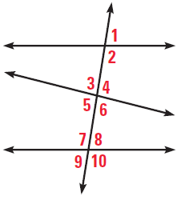 1) ∠1 and ∠4 2) ∠5 and ∠8



3) ∠7 and ∠10 4) ∠4 and ∠9



5) ∠1 and ∠9 6) ∠2 and ∠6



7) ∠6 and ∠7 8) ∠6 and ∠10



Example B**:** Describe the angle relationships.



1) 2)



1



4

3

2



3) 4)



2

1



4

3



Example C: Name an angle with the given relationship to the indicated angle.

1) Supplementary to ∠13



2) Corresponding with ∠15



3) Alternate Interior with ∠10



4) Alternate Exterior with ∠6



5) Same-side Interior with ∠13



6) Same-side Exterior with ∠8WHITEBOARDS:



**Example A:** Describe the angle relationships

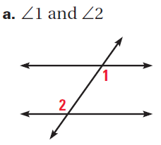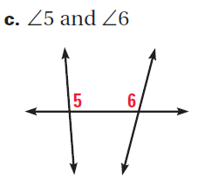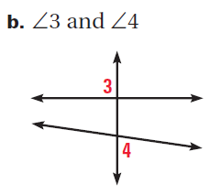

**Example B:** Describe the angle relationships

 1) <1 and <2

2) <1 and <5

3) <1 and <6

4) <1 and <4

5) <1 and <8

6) <4 and <5

7) <4 and <7