Geometry Name: ___________________________

3.3- Homework Date: _______________ Per: ________



**Find the value of each variable.**

1. 2. 3.



4. 5. 6.

**Find the measure of the numbered angle.**



1. 8.

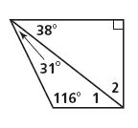



9. 10.

**Classify the triangles by the sides.**

15 in.

15 in.

15 in.

17 in.

15 in.

8 in.

11. The sides of a triangle are 12. 13.

10, 8, and 10 cm.

**Classify the triangles by the angles.**

40°

70°

70°

60°

60°

60°

14. The angle measures are 44°, 110° and 26°. 15. 16.

17. Find the value of the variables. 18. Find x.





19. Find x. 20. Find the measure of the numbered angles.

