Geometry Name:_________________________________

Chapter 3 Review



Directions: Identify the relationship between the angles.

1. <1 and <2 2. <1 and <6

3. <2 and <3 4. <1 and <5

5. <4 and <2 6. <5 and <3

Directions: Identify the angle relationship for the following angles.



7. 8. 9. 10.

Directions: Find the measure of each numbered angle.



11. 12. 13. 14.

Directions: Find the value of the variable, given that f ⊥ g.



15. 16.

Directions: Determine if the following lines are parallel. Justify your reason.

17. 18. 19.



20. 21. 22.

Directions: Find the value of the variable that makes the line m// line.



23. 24. 25.

Directions: Determine if the lines are parallel, perpendicular or neither.



26. Passes through (-6,2) and (3,5) 27. Passes through (7,3) and (8,7) 28.

Passes through (4,1) and (1,0) Passes through (-5,-4) and (-1,-5)

Directions: Use the angle formulas to find the following.

29. Find the interior angle sum of a 14-gon.

30. Find the exterior angle sum of a 38-gon.

31. Find the measure of each angle of a regular octagon.

32. Find the measure of each exterior angle of a regular 33-gon.

33. Find the measure of each interior angle of a regular 32-gon.

34. Name the polygon whose interior angle sum is 8640 degrees.

35. Name the regular polygon whose interior angle measure is 174 degrees.

36. Name the regular polygon whose exterior angle measure is 15 degrees.

Directions:Find the value of x that would make line l//m and a//b. Then state the postulate used.

37. 38.

Directions: Find the value of the variables.

39. 40.

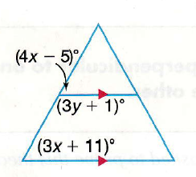41. 42.



43. 44.

45.

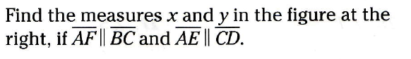

46. Find x and the measure of <A.

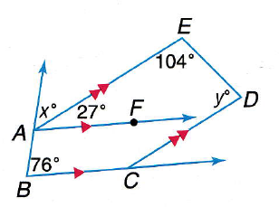





47. 48.