4.5 Isosceles & Equilateral Triangles - Notes Date: ________

|  |  |  |  |  |
| --- | --- | --- | --- | --- |
| **Learning Targets** | **Help!** | **I’m getting there…** | **I’m almost there…** | **Yes! I totally got this! ☺** |
| 1. I can apply the Isosceles Triangle Theorem. |  |  |  |  |
| 2. I can apply the converse of the Isosceles Triangle Theorem. |  |  |  |  |
| 3. I can show that if a triangle is equilateral, it is also equiangular (and the converse). |  |  |  |  |



Isosceles Triangles:



*Isosceles Triangle Theorem: _________________________________________________



________________________________________________________________________



*Converse of Isosceles Triangle Theorem: ________________________________________



________________________________________________________________________



**Example A:**



C

B

A

50°

x

1) Find x.



2) Find x and y.



x

130°

y



3) Find x and y.



(2y)°

(3x+5)°

(2x+10)°0



*Isosceles Right Triangle: _____________________________________________________



y

x



*Equilateral Triangles: _______________________________________________________



y

60°

60°

60°

x





**Example B:** Find the value of the variables.

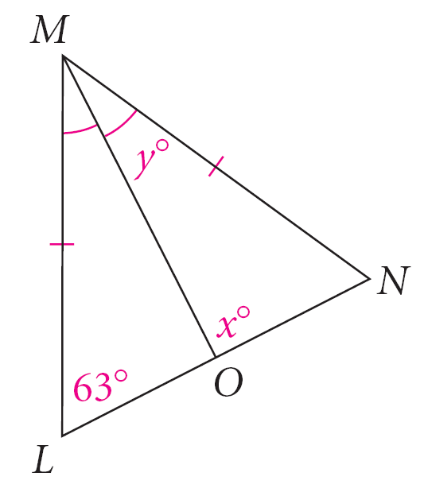1) 2)





(3y+2)°

(x + 6)°

(4x + 18)°

3) 4)

