Ch. 4 Review Name: _________________________

Date: ____________ Period: _______

Directions: Complete each statement using vocabulary from the chapter.

1. The two congruent sides of an isosceles triangle are the _____________.

2. The two congruent sides of an isosceles triangle form the _____________.

3. If you know the two triangles are congruent, then the corresponding sides and angles of the triangles are congruent because _____________.

4. The side opposite the right angle of a right triangle is the _____________.

5. The angles of an isosceles triangle that are not the vertex angle are called the _______________.

6. The ___________ are the two sides of a right triangle that are not the hypotenuse.

7. __________________ have congruent corresponding parts.

8. The side of an isosceles triangle that is not a leg is called the _________________.

Directions: ΔDOG ≅ ΔCAT. Complete the congruence statements.

9. ∠O ≅ _______ 10.  _______ 11. ΔGDO ≅ Δ_______

Directions: Use the given information to find the indicated values.

12. Given: ΔWXY ≅ ΔMNO 13. Given: ΔCBA ≅ ΔHKI

Find the values of a and b. Find the values of x and y.

C

A

B

(2x + 18)°

(3y + 11)°

52°

K

I

H

W

(4b + 8)°

38°

X

Y

N

M

O

74°

(7a – 4)°

a = _____ b = _____ x = _____ y = _____

Directions: Fill in the second triangle and state the theorem to prove the triangles congruent. If the triangles cannot be proven congruent, write not possible.

14. ΔZYX ≅ _______ 15. ΔACB ≅ _______ 16. ΔHFG ≅ _______

F

G

H

R

P

Q

X

Y

Z

R

S

T

A

C

B

F

D

E

17. ΔPQR ≅ _______ 18. ΔKLJ ≅ _______ 19. ΔYWX ≅ _______

J

L

K

E

F

G

C

E

D

P

R

Q

B

C

A

W

Y

X

Directions: Determine which side or angle is needed to prove the following triangles congruent.

W

X

Y

Z

D

E

F

G

N

O

P

Q

20. 21. 22.

A. HL _______ A. SSS _______ A. AAS _______

B. SAS _______ B. SAS _______ B. ASA _______

Directions: Find the missing value.

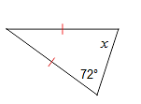

23. 24. 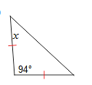 25. 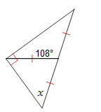

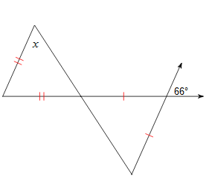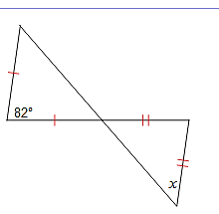

26. 27. 28.

(3x + 8)°

(2x + 20)°

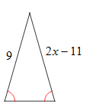

29. 30.

(3x - 11)°

(2x + 11)°

2y°

G

M

K

R

31. Given: bisects ∠MGR, 

Prove: ΔMGK ≅ ΔRGK

|  |  |
| --- | --- |
| Statements | Reasons |
| 1. | 1. |
| 2. | 2. |
| 3. | 3. |
| 4. | 4. |
| 5. | 5. |

32. Given: ∠J ≅ ∠L, B is the midpoint of 

C

L

B

J

H

Prove: ΔJHB ≅ ΔLCB

|  |  |
| --- | --- |
| Statements | Reasons |
| 1. | 1. |
| 2. | 2. |
| 3. | 3. |
| 4. | 4. |
| 5. | 5. |

M

A

T

H

33. Given: , 

|  |  |
| --- | --- |
| Statements | Reasons |
| 1. | 1. |
| 2. | 2. |
| 3. | 3. |
| 4. | 4. |
| 5. | 5. |
| 6. | 6. |
| 7. | 7. |

Prove: ∠A ≅ ∠H

34. Given: ∠R ≅ ∠T, 

T

S

R

V

Prove: 

|  |  |
| --- | --- |
| Statements | Reasons |
| 1. | 1. |
| 2. | 2. |
| 3. | 3. |
| 4. | 4. |
| 5. | 5. |
| 6. | 6. |