5.1 Midsegments of Triangles- Notes Date: _____________

|  |  |  |  |  |
| --- | --- | --- | --- | --- |
| **Learning Targets** | **Help!** | **I’m getting there…** | **I’m almost there…** | **Yes! I totally got this! ☺** |
| 1. I can identify midsegment of a triangle |  |  |  |  |
| 2. I can apply the Triangle Midsegment Theorem |  |  |  |  |



Midsegment of a Triangle: ________________________________________________________



_____________________________________________________________________________



A segment connecting the midpoints of two sides



Triangle Midsegment Theorem: If a segment joins the midpoints of two sides of a triangle, then



1. ___________________________________________________________



1. ___________________________________________________________



If a segment joi half its length



E

K

G

J

H

F

EX 1:



In ΔEFG, H, J, and K are midpoints.



HK = 40, EF = 60, EG = 100



Find HJ, JK, and FG. What is the perimeter



of ΔHJK?



C

F

B

D

E

A

EX 2:



In ΔABC, D, E, and F are midpoints.



Name pairs of parallel segments.



EX 3:



D

C

B

E

A



E and B are midpoints.



AB = 10, CD = 18. Find EB, BC, and AC.



EX 4:



Y

N

Z

P

M

X



In ΔXYZ, M, N and P are midpoints. The perimeter



22

Of ΔMNP is 60. Find NP, XZ, YZ, and XY.



24



Ex 5: Solve for x.



70

5x



Ex 6: Find *x*. Ex 7: A and S are midpoints. Find m∠R and m∠C.



C

A

R

T

S

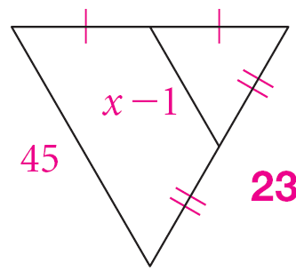

7x - 12