Ch. 5 Review Name: ___________________

Date: __________ Hour: ____

Short Answer.

________________1. What segment is drawn by connecting the midpoints of two sides of a triangle?

________________2. If a point is on the perpendicular bisector of a segment, then it is ? from the endpoints of the segment.

________________3. What segment extends from a vertex of a triangle and is perpendicular to the opposite side?

________________4. The midsegment of a triangle is (4) to the third side and is (5) _ its length.

________________5.

_______________6. If a point is on the bisector of an angle, then it is equidistant from the ? of the angle.

_______________7. O and W are midpoints. Solve for x.

S

N

O

W

Y

8x

16

8. Solve for x, y, and z.

O

T

S

83o

z

35o

y

x

M

R

46

9. In SIH, L, E, and G are midpoints. LE = 20, SL = 16, and SH = 28. Find the perimeter of .

S

L

E

I

G

H

10. List the angles of the triangle in order from smallest to largest.

7

10

4

T

Y

O

11.. Solve for x.

4x+1

S

I

T

N

E

L

3x+2

2x

The perimeter of STL is 96.

12. Identify the indicated segments in RLH.

R

Median:__________

U

Altitude:__________

O

D

__________

___________

P

H

L

13. List the sides of the triangle from shortest to longest.

P

E

I

19

72

14. What are the coordinates of the center of the circle that circumscribes ?

15. Which segment is the shortest? The diagram is not drawn to scale.

C

E

K

A

110

32

114

30

16. Can the following segment lengths form a triangle?

_______________ (a) 4, 8, 6

_______________ (b) 2.6, 4.1, 6.7

_______________ (c ) 21, 7, 10

17. During lunch, Kris was making triangles with some straws. If he has a 3-in. straw and a 4-in. straw, which straw can he not use to form a triangle?

(A) 5-in. straw (B) 4-in. straw

(C) 7-in. straw (D) 6-in. straw

18. A triangle has sides of lengths 8m and 19m. Describe the lengths possible for the third side. Use x to represent the length of the third side.

19. In the diagram,  is the perpendicular bisector of . Find x and y.

N

L

E

O

½x+9

¼y+9

6x-2

2y-5

20. Solve for x.

2x+3

24

21. Solve for x.

6x

8x-7

3(3x-4)

2(7x-24)

22. Solve for x.

Use a straight edge to draw the indicated segments. Mark the diagram to confirm what you are drawing.

23. altitude from O 24. any midsegment 25. median from D

N

W

O

T

U

B

D

E

W

26. perpendicular 27. angle bisector of F 28. altitude from A

S

T

A

bisector of 

F

I

R

H

T

U

29.perpendicular bisector 30. median from Y 31. angle bisector of L

P

Y

H

of 

A

H

P

I

L

O

32. perpendicular 33. altitude from N 34. altitude to 

bisector of 

E

S

N

W

Y

R

D

A

Y

35. Find the coordinates of the median drawn from R to in .

F (-2,-4) R (3,9) O (8,-3)

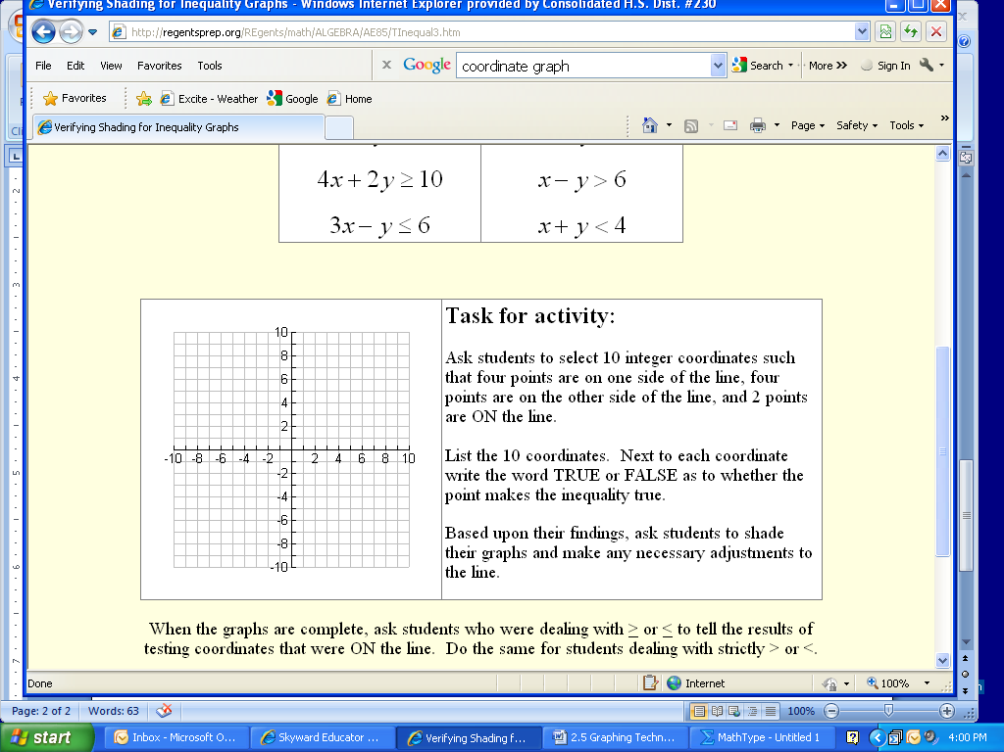

36. Find the coordinates of the endpoints of the midsegment parallel to  in .

S (-1,-4) T (9,-4) Y (3,8)

