6.2 Properties of Parallelograms – Notes Date: _________



|  |  |  |  |  |
| --- | --- | --- | --- | --- |
| **Learning Targets** | **Help!** | **I’m getting there…** | **I’m almost there…** | **Yes! I totally got this! ☺** |
| 1. I can state precise definitions of a rectangle, parallelogram, trapezoid and regular polygons. |  |  |  |  |
| 2. I can state the properties of a parallelogram. |  |  |  |  |
| 3. I can identify that the slopes of opposite sides of parallelograms are equal. |  |  |  |  |

**Vocabulary:**



Parallelogram: a quadrilateral with both pairs of opposite sides parallel.



Consecutive angles: angles of a polygon that share a side.



∠A and ∠B are consecutive angles



There are FIVE properties of parallelograms:



A

B

C

D

1. By definition, opposite sides are parallel



2. Opposite sides are congruent



3. Opposite angles are congruent



4. The diagonals bisect each other



5. Consecutive angles are supplementary



A

B

C

D

x + 12

2x + 6

EX 1: ABCD is a parallelogram. Find AB.



EX 2: Find the value of a and b.



(6a + 10)°

130°

b°



1. PT = 2x, TR = x + 2, QT = 3y - 8, TS = y

Find the values of x and y in PQRS.

Q

T

S

R

P



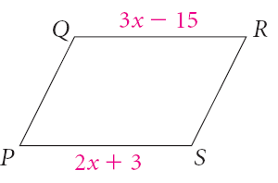2. Find x in the given parallelogram. 3. Find m∠S in RSTW



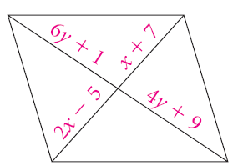4. Find the value of y in EFGH. 5. Find the value of the variables.

Then find m∠E, m∠G, m∠F, and m∠H.



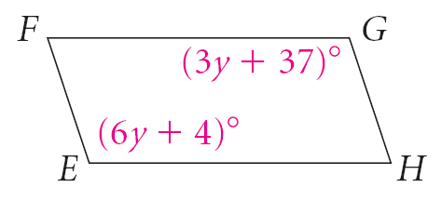



6. Given the following vertices of quadrilateral ABCD, determine whether or not it is a parallelogram.

A(-3, -4)

B(2, 2)

C(0, -3)

D(-5, -1)

WHITEBOARDS:

4x - 18

2x + 12

1.) Find x in the given parallelogram.

2.) Use KMOQ to find m∠O

35°

M

Q

O

K

3.) Find the value of x in ABCD. Then find m∠A.

(135 – x)°

B

D

C

A

(x + 15)°

4.) Find the value of the variables using the given information.

BE = 4x + 12 ED = x + 27 CE = y + 4 EA = 6y - 26

