6.3 Proving that a Quadrilateral is a Parallelogram – Notes Date: ________

|  |  |  |  |  |
| --- | --- | --- | --- | --- |
| **Learning Targets** | **Help!** | **I’m getting there…** | **I’m almost there…** | **Yes! I totally got this! ☺** |
| 1. I can state precise definitions of a rectangle, parallelogram, trapezoid and regular polygons. |  |  |  |  |
| 2. I can prove that cases for which a quadrilateral is a parallelogram, including: opposite sides are congruent and parallel, opposite angles are congruent, consecutive angles are supplementary, and diagonals bisect each other. |  |  |  |  |

*Ways to prove that a quadrilateral is a parallelogram:



1) _________________________________________________________________________



2) _________________________________________________________________________



3) _________________________________________________________________________



4) _________________________________________________________________________



5) _________________________________________________________________________



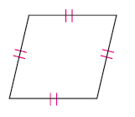**Example A:** Determine whether the quadrilateral is a parallelogram. Why or why not?

a) b) c)



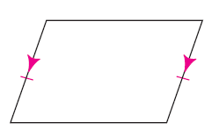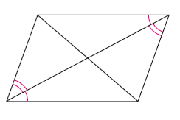d) e) f)



**Example B:** Determine what additional information would be needed to prove that the quadrilateral is a parallelogram.



a) 



b) 



c) 



d) 



**Example C:** Find the values of x and y for which *ABCD* must be a parallelogram.

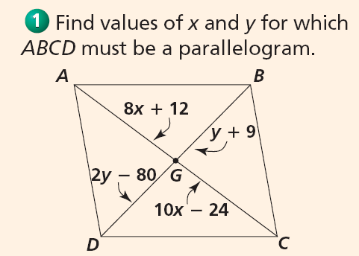



**Example D:** Find the values of the variables for which *GHIJ* must be a parallelogram. 



**Example E:** Find the values of the variables that ensure the figure is a parallelogram.

