6.4 Rhombus, Rectangle, & Square - Notes Date: _______

|  |  |  |  |  |
| --- | --- | --- | --- | --- |
| **Learning Targets** | **Help!** | **I’m getting there…** | **I’m almost there…** | **Yes! I totally got this! ☺** |
| 1. I can state precise definitions of a rectangle, parallelogram, trapezoid and regular polygons. |  |  |  |  |
| 2. I can define parallelogram, rectangle, rhombus, and square. |  |  |  |  |
| 3. I can identify (or distinguish) parallelograms, rectangles, rhombi, and squares. |  |  |  |  |
| 4. I can prove the cases for which a parallelogram is a rectangle. |  |  |  |  |
| 5. I can prove the cases for which a parallelogram is a rhombus. |  |  |  |  |
| 6. I can prove the case for which a parallelogram is a square. |  |  |  |  |

Properties of a Rhombus

M

O

H

R

1.



2.



3.



4.



5.



R

T

C

E

Properties of a Rectangle

1.



2.



3.



4.



Q

R

S

E

Properties of a Square

1.



2.



Each figure is a rhombus. Find the measure of each numbered angle.



50°

1

2

3

4

120°

1

2

3

4

5

1. 2.



m∠1 = _____ m4 = _____ m∠1 = _____



m∠2 = _____ m5 = _____ m∠2 = _____



m∠3 = _____ m∠3 = _____



Find the indicated measures in each rectangle.



G

F

D

E

1

2

38°

104°

3

4

3. 4. Y = ______



FD = _____



GE = _____



m∠1 = _____ FD = 2y + 4, GE = 6y - 5



m∠2 = _____



m3 = _____



m4 = _____



5. Find the value of the variables or angle measures in each rhombus.

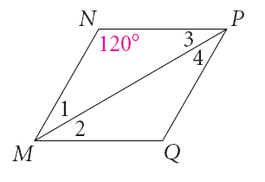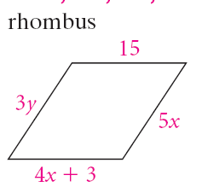

a) b)

8.) Find the missing angles in the given rectangle.

a) b)

15°

a

e

b

c

d

140°

x

y

WHITEBOARDS:

Example A: Find each angle measure in the given rhombus.



1) 2)

Example B: *LMNP* is a rectangle. Find the value of *x* and the length of each diagonal.

*LN* = 5x – 8 and *MP* = 2x + 1

Example C: Find the missing angles in the given rectangle.

1) 2)

120°

c

e

b

a

d

b

a

25°

c

d

e