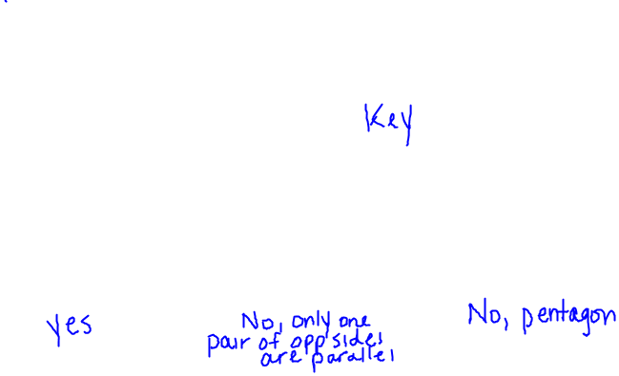Geometry Name: _________________________________

Worksheet 6.1-6.2 Date: _________________ Per: __________

Directions: Decide whether the figure is a parallelogram. If it is not, explain why not.

1) 2) 3)

Directions: Use the diagram of parallelogram *MNOP* at the right. Complete the statement, and give a reason for your answer.

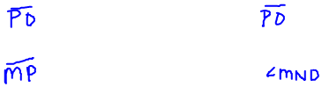

M

N

O

Q

P

4)  5) 

6)  7) ∠MPO ≅ _____

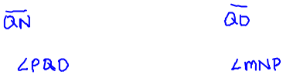

8)  9) 

10) ∠MQN ≅ _____ 11) ∠NPO ≅ _____

Directions: Find the measure in the parallelogram *HIJK*. Explain your reasoning.

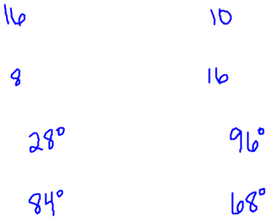

12) HI _____ 13) KH _____

I

J

K

G

7

8

28°

84°

16

10



H

14) GH _____ 15) HJ _____



16) m∠KIH _____ 17) m∠JIH _____



18) m∠KJI _____ 19) m∠HKI _____



Directions: Find the value of each variable in the parallelogram.

20) 21)

3x - 7

2y + 18

2x + 9

5y



12

27

3x + 6

2y + 9







2y + 3

4x°

2x°

y + 9

22) 23)

2y + 21

4y + 5

(3x – 9)°

(2x + 31)°





24)



6y + 10

7y + 1

2x + 10

3x



25) Given B is the midpoint ofand E is the midpoint of, find each of the following.

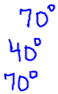

A

B

F

C

D

E

140°

70°

a) m∠ABC _____

b) m∠D _____



c) m∠A _____



d) m∠CBE _____

26) Given D is the midpoint ofand E is the midpoint of, and DE = 4x – 3, BC = 10x – 18,

AE = 2x + 1, and AB = 5x + 1, find the perimeter of ΔABC.

A

D

E

B

C

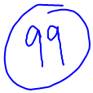

27) The measures of *angles* A, B, and C are given. Find x in order to list the *sides* in order from LEAST to GREATEST.

m∠A = 2x + 12, m∠B = 5x – 9, m∠C = 2x – 12.



28) a) Find the possible values of length for the b) Find the value of the variables.



third side of the triangle.

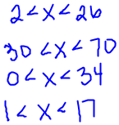



2x + 1

y + 3

4y

4x – 5

a) 12, 14



b) 20, 50

c) 17, 17

d) 8, 9



29) Given parallelogram ABCD,  and are diagonals. DB = 44. Find x.



3x + 4

A

B

C

D

E





30) Find the value of each variable in the given parallelogram.



(4x)°

(3z)°

(3y - 15)°

(2y + 10)°







18°

A

B

C

D

E

71°

33°

21

12

32

31) Find the missing angle measure or side length.

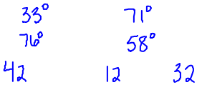

a) m∠CAB b) m∠ACB

c) m∠ABC d) m∠CBD

e) DB f) AD g) DC

32) Tell whether  is an altitude, median, perpendicular bisector, or none.

A

B

A

B

A

B

A

B

A

B

A

B

