5.2 – 5.3 Worksheet Name: ____________________

Date: _________ Period: _____

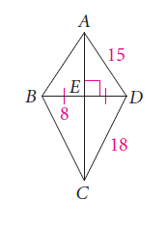1. From the information given in the figure, how is  related to  ?

2. Find AB.

3. Find BC.

4. Find ED.

5. Find x, JK and JM. 6. Find y, ST, and TU.

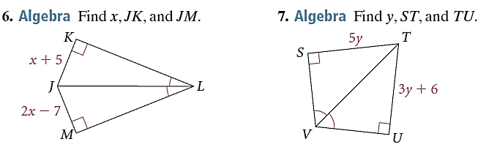

7. Find the value of x.

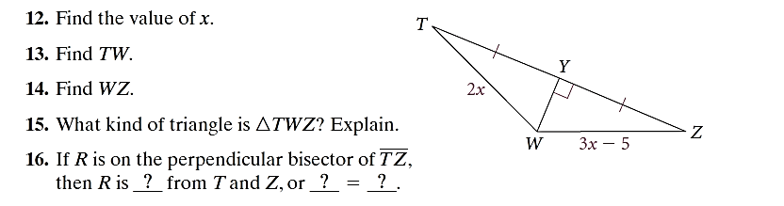

8. Find TW.

9. Find WZ.

10. What kind of triangle is ΔTWZ? Explain.

Directions: Name each figure in ΔFDB.

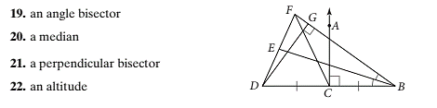

11. an angle bisector

12. a median

13. a perpendicular bisector

14. an altitude

15. What are the coordinates of the endpoints of the midsegment of ΔABC parallel to ?

B (-1, 2)

(5, 3)

(1, 8)

F

E

D

C

A

16. Using the figure above, what are the coordinates of the endpoints of the midsegment of ΔABC parallel to ?