1.4 Day 1: Measuring Segments - Notes Date: ___________

|  |  |  |  |  |
| --- | --- | --- | --- | --- |
| **Learning Targets** | **Help!** | **I’m getting there…** | **I’m almost there…** | **Yes! I totally got this! ☺** |
| 1. I can find the lengths of segments. |  |  |  |  |
| 2. I can name congruent segments. |  |  |  |  |
| 3. I can find and define midpoint of a segment. |  |  |  |  |
| 4. I can apply the Segment Addition Postulate. |  |  |  |  |



Warm Up:

1.  2.  3.  4. 



_____________________________________________________________________



**Postulate 1-5: Ruler Postulate-____________________________________________



_____________________________________________________________________



AB =



B

A



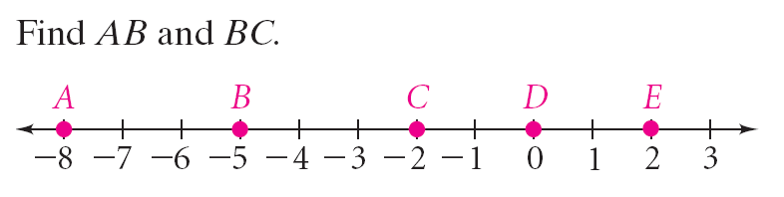



Example A: Find *AB* and *BC*.



Example B:Find M if the length of = 9 and the coordinate of N is 6.



**Congruent Segments: ___________________________________________________



*\*\* Postulate 1-6:* Segment Addition Postulate-_________________________________



_____________________________________________________________________



Example C:

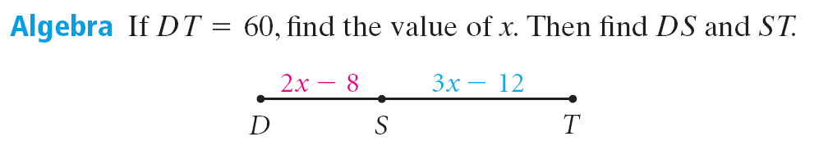



**Midpoint: ____________________________________________________________



Example D:

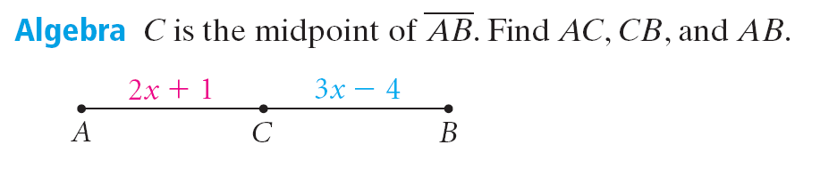

**1)**







**2) WHITEBOARDS:**



**Example A:** Find *AE* and *DB*

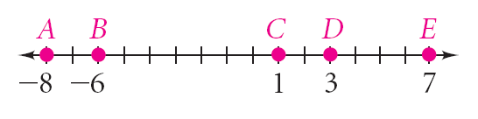

**Example B:**

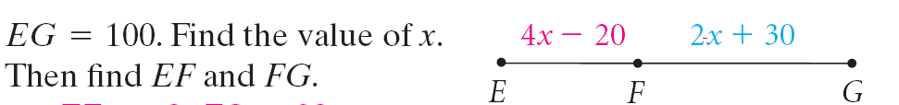

**Example C:**

1) *M* is the midpoint of . Find *RM*, *MT*, and *RT*.

*RM* = 5x + 9; *MT* = 8x – 36;

2) *W* is the midpoint of . *TN* is 33. Find *TW*.

**Example D:** Find B if the length of = 14 and the coordinate of B is 3.