**Geometry Name: _________________________________**

**1.4 – 1.6 Review Date: _________________ Per: __________**

**Classify the following angles.**

H

A

Y

M

S

A

M

N

P

1) 2) 3)

**Use the Angle Addition Postulate to find the measure of the unknown angle.**

4)  5)  6) 



**Find the Midpoint between the two endpoints.**

7) *A* (-8, -4), *B* (2, -3) 8) *X* (4, 9), *Y* (-1, 3)

**Find the coordinates of the other endpoint when given one endpoint and midpoint *M*.**

9) *H* (-4, -3) *M* (1, -7) 10) *B* (9, -1) *M* (4, -2) 11) *A* (2, 3) *M* (3, 1)

**Find the distance between the two endpoints. Round to the nearest tenth.**

12) (-5, 8) (-1, -2) 13) (0, 4) (-3, -3) 14) (2, 10) (-4, 8)

15)  bisects  16)  bisects 

Find:  and  Find:  and 

D

C

R

P

T

S

19˚

162˚

B

A

17)  bisects  18)  bisects 

Find: *x*,  and  Find: *x*,  and 

(3x + 36) ˚

(9x - 18) ˚

A

T

B

C

T

(5x - 17) ˚

A

(3x + 14) ˚

B

C

19) If *PT* = 13 20) If *I* is the midpoint of 

Find: *x*, *PA*, *AT* Find: *x*, *KI*, *KM*

2x - 3

3x + 1

P

A

T

5x - 4

3x + 6

M

I

K

21) If  22) If 

Find: ,  Find: , 

A

M

K

R

(5x + 4) ˚

(8x - 5) ˚

D

F

(12x – 1) ˚

(2x + 3) ˚

R

E

23) Find *AB* 24) Find the coordinate of *y* 25) How many angles

are shown?

x

y

-3

?

7

A

B

-12

5

Use the figure to determine whether the statement is *true* or *false*.

26) *D*, *G*, and *F* are collinear. 27) *A*, *O*, and *C* are coplanar.

28)  lies in plane *P*. 29)  lies in plane *P*.

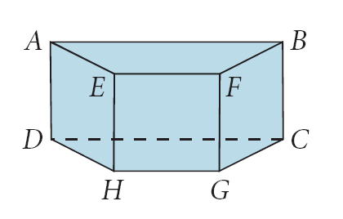Use the figure to determine the intersection between the pair.

30) plane *FBC* and 

31) plane *ABFE* and plane *GCBF*

Determine whether the pair of lines is *intersecting*, *skew*, or *parallel*.

32)  and  33)  and  34)  and 