Geometry Name:__________________________________
1.6- Homework Date: __________________ Per: _________

Find the distance between the points to the nearest tenth.
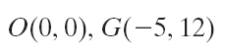
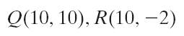
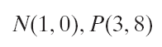
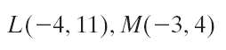
1. 2. 3. 4.

Find the coordinates of the midpoint of each segment. The coordinates of the endpoints are given.
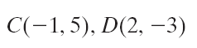
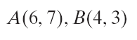
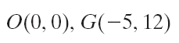
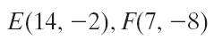
5. 6. 7. 8.

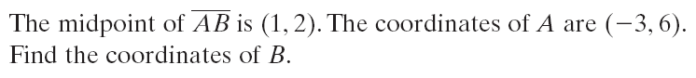
9.

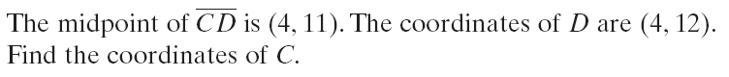
10.

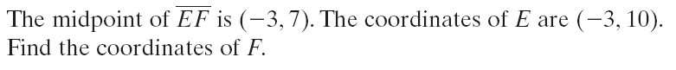
11.

Using the graph, find a) AB to the nearest tenth and b) the coordinates of the midpoint M of .
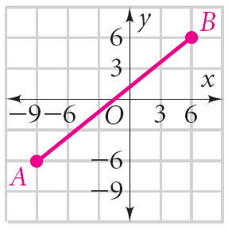
12. AB=_______________

M( , )

